
university panic button system
NPRT630

TECHNO WARRIORS

GROUP MEMBERS:
PALESA HOPE NTSANE – 202437528
BROWN NKOSI- 202474004
RETHABILE THUTO PHEKO -202345683
THAPELO RAMPHAGO – 202411369

Contents
PHASE 3: DESIGN SPECIFICATION 1
3.1 Interface Design (Screens & Descriptions) 1
3.2 User Feedback and Iterative Design 3
3.3 Entity Relationship Diagram (ERD) 4
3.5 Relationship Justification 6
3.6 Technology Selection and Justification 7
3.7 Design Evaluation 8
Conclusion 8

PHASE 3: DESIGN SPECIFICATION

3.1 Interface Design (Screens & Descriptions)

The system interface was designed following user-centred design principles, ensuring usability, visibility, and rapid response during emergencies.

Login Interface

This screen allows registered users to securely access the system using their credentials (student/staff number and password). It includes error handling, password recovery, and role-based redirection (student, admin, security).

Registration Interface

The registration screen captures user details such as full name, institutional ID, email, and contact number. Input validation ensures data integrity and prevents duplicate or invalid entries.

Authentication Interface

This layer enhances security through verification mechanisms such as OTP (One-Time Password) or secure session authentication. It ensures only authorised users access sensitive features.

Home Interface

The home screen is optimised for emergency response. It features:
- A centralised panic button
- Quick-access emergency contacts
- Navigation shortcuts
The layout prioritises speed, visibility, and minimal cognitive load.

User Dashboard

The dashboard provides:
- Alert history
- Real-time alert status tracking
- Feedback submission
It enhances transparency and user awareness during emergency situations.

Admin Dashboard

The admin interface enables security personnel to:

- Monitor live alerts
- View user and location data
- Dispatch response teams
It supports real-time decision-making and operational control.

Data Entry Forms

Structured forms allow users to submit incident details including:
- Emergency type
- Location
- Description
- Optional media
Form validation ensures completeness and accuracy.

Report Generation Interface

This interface allows administrators to generate analytical reports based on:

- Time periods
- Locations
- Incident categories
These reports support data-driven safety improvements.

User Management Panel

Admins can:
- Manage user accounts
- Assign roles
- Monitor activity
This ensures controlled system access and accountability.

Feedback Interface

Users can submit ratings and suggestions. This enables continuous system improvement and supports iterative design.

3.2 User Feedback and Iterative Design

The system underwent iterative refinement based on usability feedback.

Iteration 1: Panic Button Visibility
Issue: Users struggled to quickly locate the panic button
Improvement: Enlarged the button, centred it, and applied a high-contrast colour
Impact: Reduced response time and improved usability in high-stress situations

Iteration 2: Save Button Discoverability
Issue: Users overlooked the save button in forms
Improvement: Changed colour to green and repositioned it to the top-right
Impact: Increased task completion rate and reduced user errors

Iteration 3: Alert Status Feedback
Issue: Lack of confirmation after sending alerts
Improvement: Introduced status indicators:
- Sent
- Received
- Dispatched
- Resolved
Impact: Improved user confidence and system transparency

3.3 Entity Relationship Diagram (ERD)

The ERD models the system’s data structure, ensuring efficient storage and retrieval.
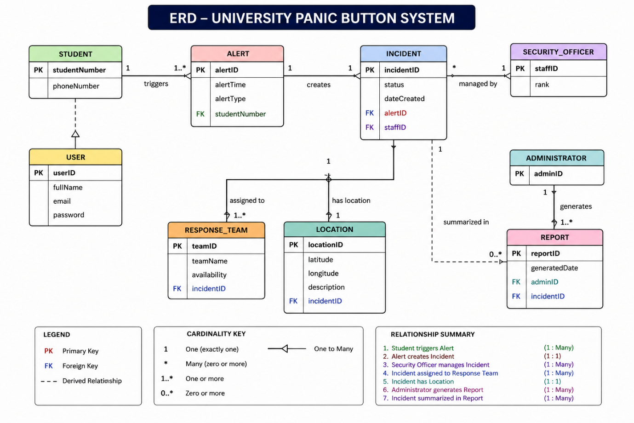

Core Entities
- User
- Role
- EmergencyAlert
- Location
- PanicDevice
- SecurityOfficer
- IncidentReport
- Feedback
- Notification

Role (1) ────< User
User (1) ────< EmergencyAlert
User (1) ────< IncidentReport
User (1) ────< Feedback

EmergencyAlert (1) ──── (1) Location
EmergencyAlert (1) ────< Notification
PanicDevice (1) ────< EmergencyAlert
EmergencyAlert (M) ────< >──── (M) SecurityOfficer

3.5 Relationship Justification

One-to-Many Relationships

A User → EmergencyAlert relationship allows multiple alerts per user
A User → Feedback relationship supports continuous evaluation

These relationships reflect real-world system usage patterns.

One-to-One Relationship
EmergencyAlert → Location ensures each alert is tied to a precise location

This supports accurate emergency response.

Many-to-Many Relationship

EmergencyAlert ↔️ SecurityOfficer
Handled through an associative table (e.g., AlertResponse)

This allows:

- Multiple officers per emergency
- Flexible resource allocation

3.6 Technology Selection and Justification

Frontend Technologies

* HTML & CSS: Structured and visually clear interface
* JavaScript: Enables interactivity and real-time updates

Backend Technologies

- Python (Django Framework)
- Built-in authentication system
- Secure and scalable
- Rapid development

Database

- MySQL / SQLite
- Efficient relational data management
- Supports structured queries and relationships

Communication & Integration

GPS Integration: Enables accurate location tracking
SMS API: Ensures alerts work without internet

Security Mechanisms

- Password hashing
- Role-based access control
- Session management

3.7 Design Evaluation

The system design prioritises:
- Usability: Minimal steps during emergencies
- Reliability: Multiple alert channels (app + SMS)
- Scalability: Structured database and modular design
- Security: Controlled access and encrypted data

The iterative improvements demonstrate a user-centred design approach, ensuring the system is both functional and practical in real-world emergency scenarios.

Conclusion
The Phase 3 design effectively integrates interface usability, structured data modelling, and justified technology choices, resulting in a robust, scalable, and user-focused emergency response system suitable for a university environment

